#### **Automatic upgrade of Windows 2008 R2 to Windows 2012**

Velostrata 4.9 introduces automatic [upgrade of Windows 2008 R2 to Windows 2012](https://cloud.google.com/migrate/compute-engine/docs/4.9/how-to/upgrading-vms/upgrading-windows-vms?hl=id) as part of the migration to Google Cloud. The system supports mass automatic upgrade of all VMs that are part of a migration wave in parallel.

**Prerequisites :**

* Ensure that the VMs you're upgrading are using Windows Server 2008 R2
* Ensure that you have enough boot disk space to support upgrade. Upgrade is likely to require 35-40 GB for each upgrading VM
* Ensure that the VMs to upgrade don't use the bring-your-own-license (BYOL) process. The upgrade feature does not support VMs using BYOL.
* Ensure adequate down time. During a migration in which you're upgrading Windows Server VMs, those VMs will be unavailable for as long as it takes to migrate and upgrade. A migration process that includes upgrade can take 1-2 hours to complete for each upgrading VM

**Steps Involved in Upgrade :**

* Full Migration (including moving to cloud, migrating, caching and detach preparation) : Took around 2 hours
* Detach : Took 10 mins
* At GCP, Increase the root drive from 30 GB to 100 GB and perform post disk management steps
* UpgradeOS : taken around 1 hour.
* Validate the upgraded 2012 machine, if migration not worked as expected, we have option to 'Cancel Upgrade OS'
* When you have validated VMs with upgraded OSes, complete the migration by running the clean up operation

**Detailed steps of Migration:**

1, Taken windows 2008R2 AWS image with 30 GB in size

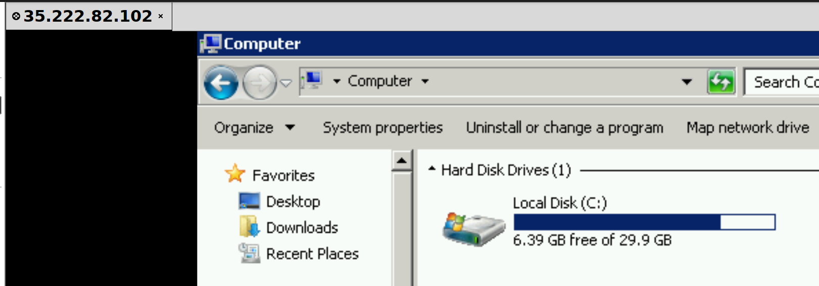

2, Full Migration job took around 2 hours considering migrating region from Seoul Asia to US Central

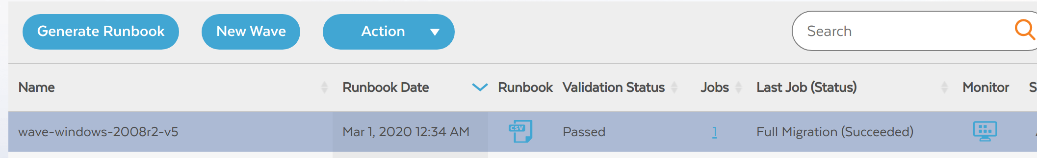

3, Migration status is Ready to Detach

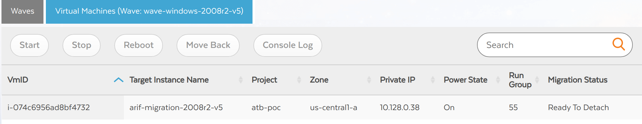

4, Create a new job with Detach operation

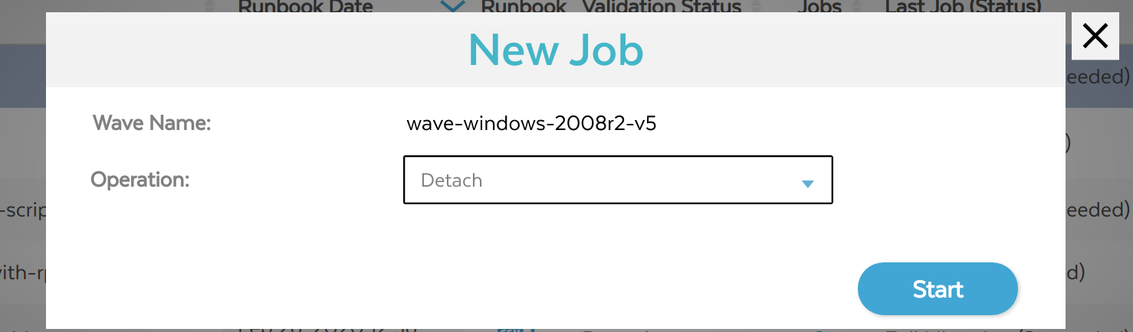

5, Detach operation will take around 10 mins

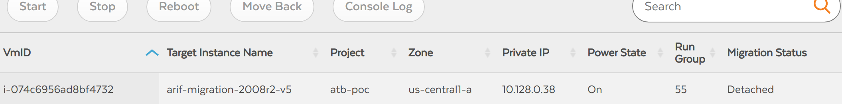

6, Increasing Disk size to 100 GB at target instance

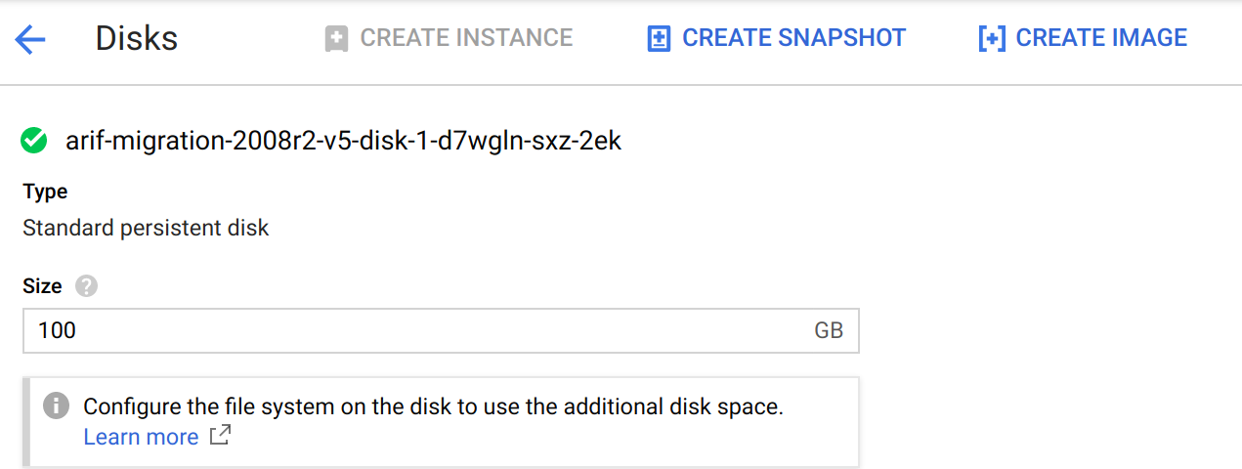

7, Login to target instance and perform following Disk management operations

Control Panel --> Disk Management --> Actions : Refresh

Select C Drive : Extend Volumes

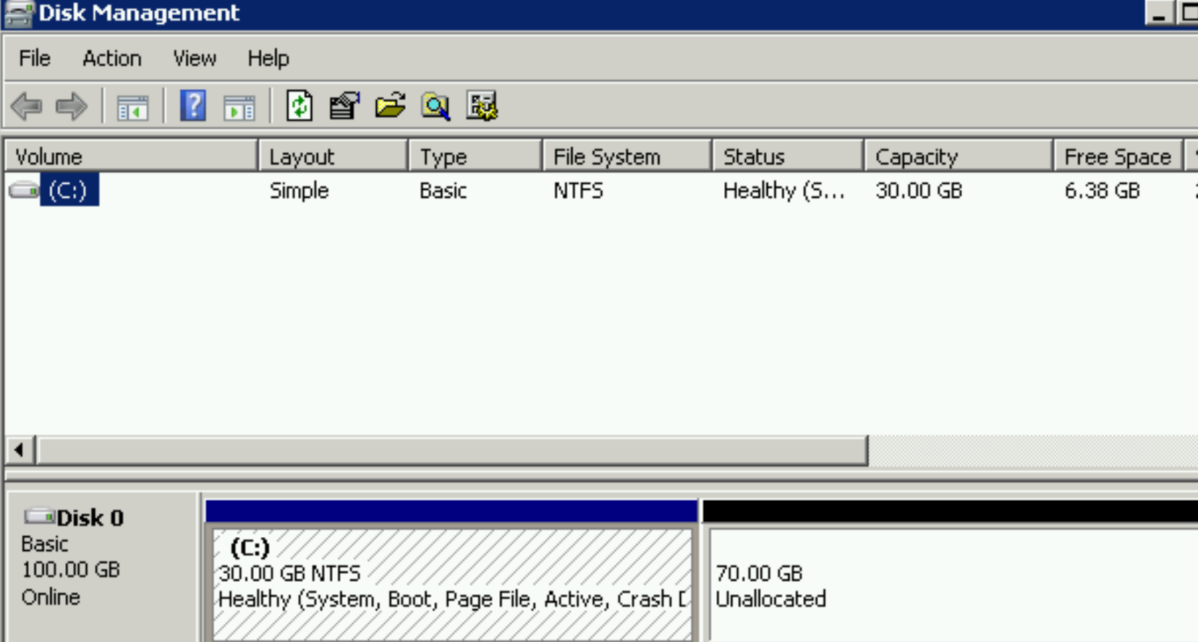

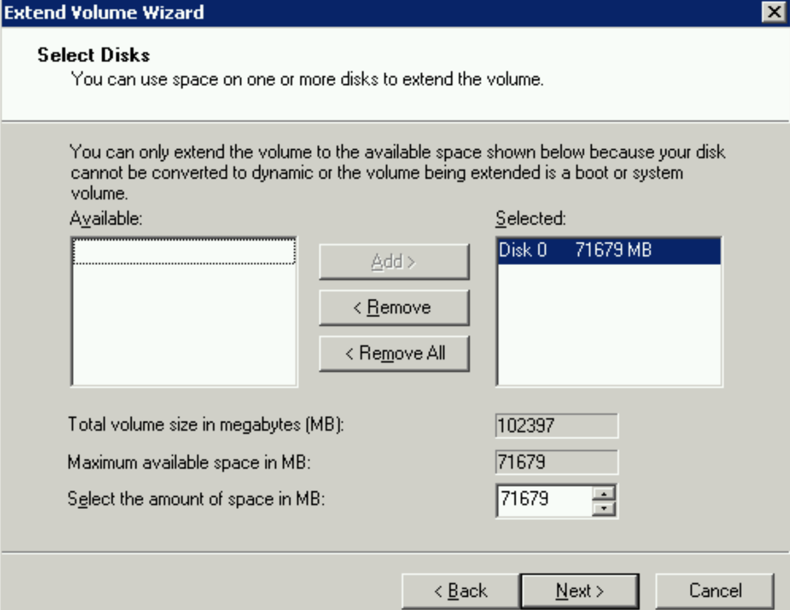

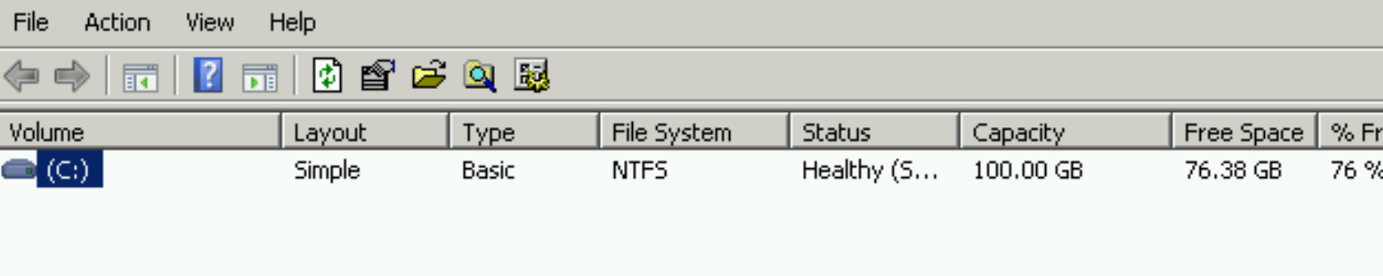

8, Once Disk size increased, perform UpgradeOS job will take around 1 hour to complete with several restarts (will restarts 3 times)

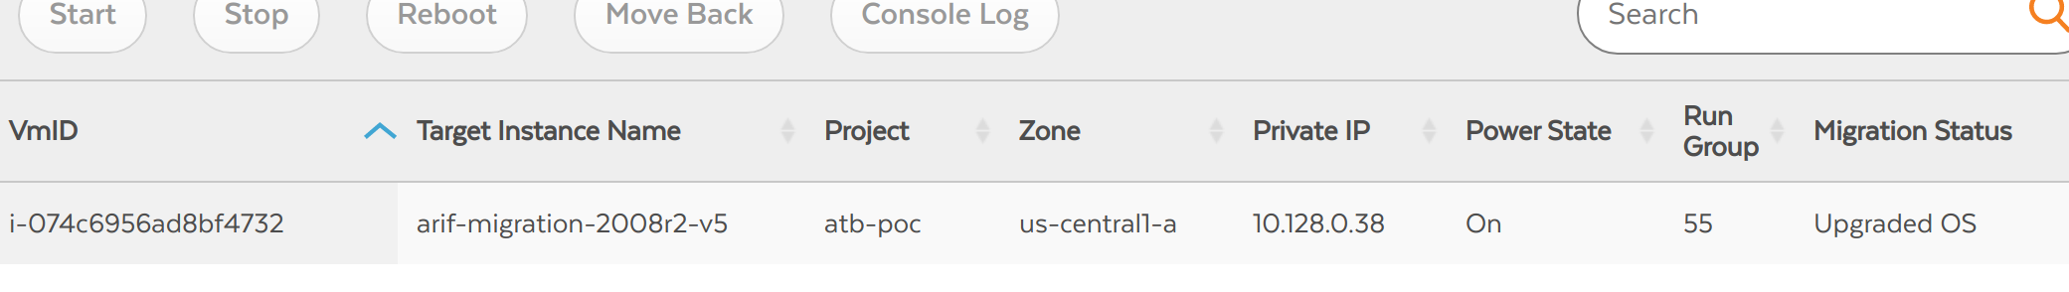

9, Login to instance, once UpgradeOS job completed

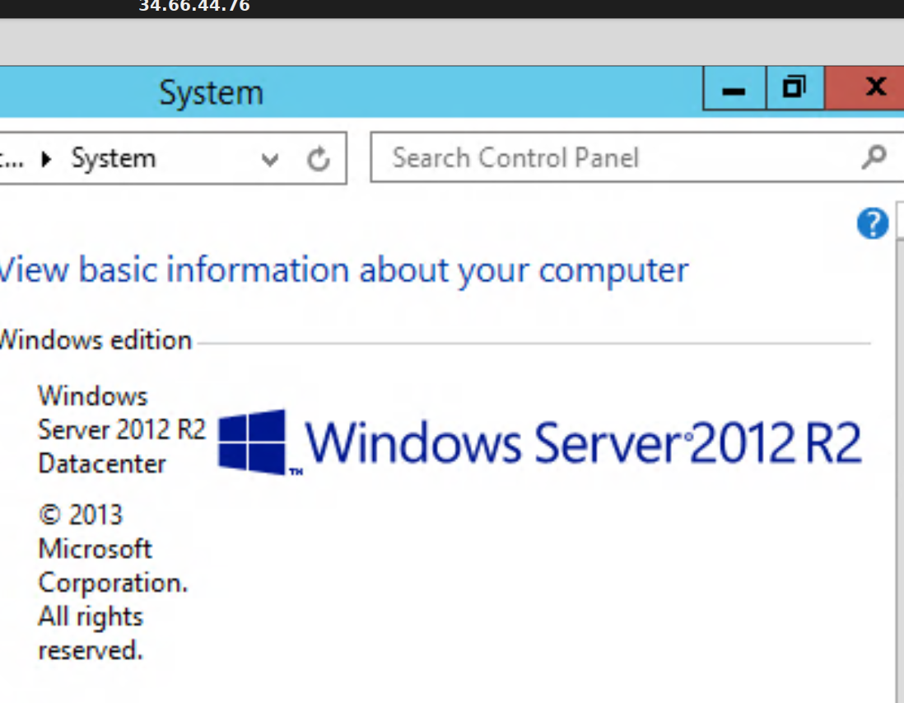

10, Validate the changes in the target 2012R2 machine for changes. we have option of rollback if didnt worked in windows 2012r2

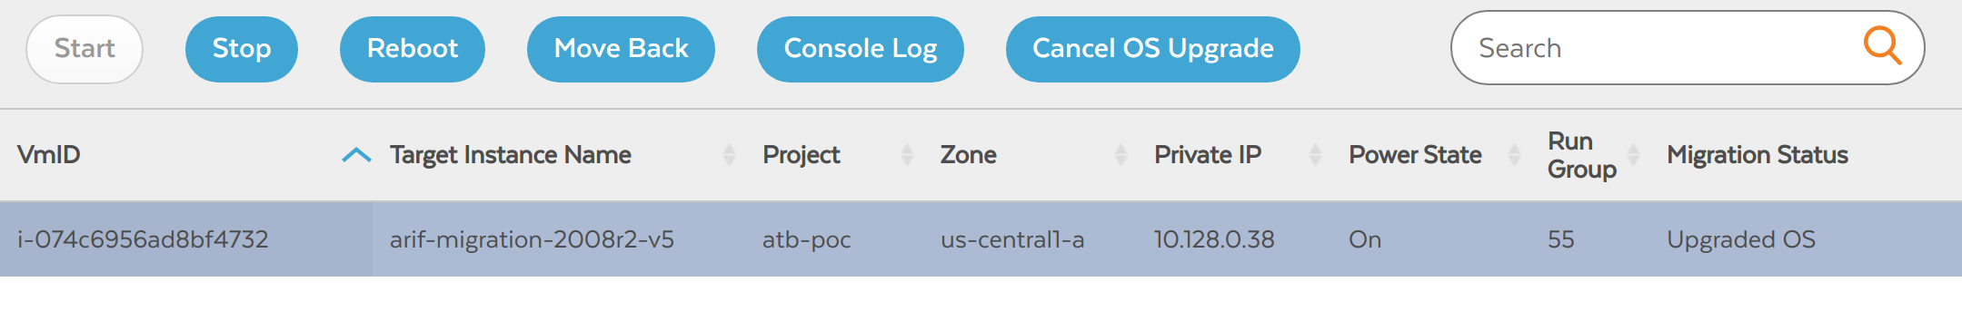

11, Perform cleanup job Cleanup

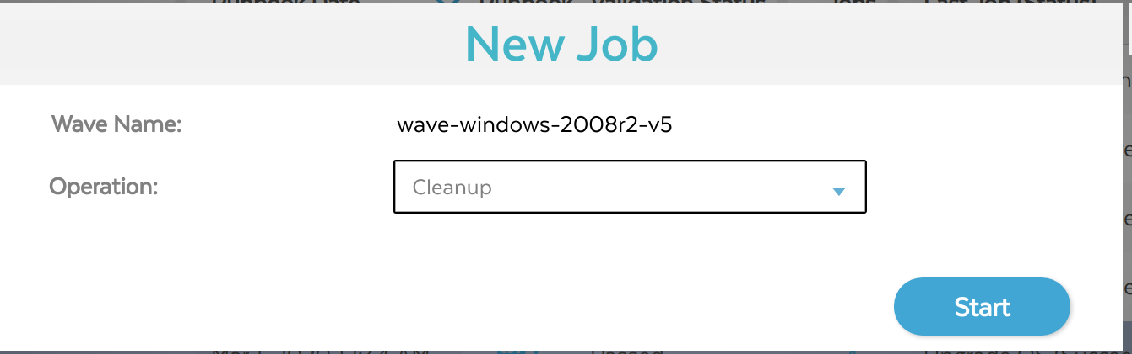

#### **Test Clone - Feature of Velostrata 4.9**

You can use test clones to try out migrated VMs on Compute Engine before putting them in production. When you create a test clone, Migrate for Compute Engine clones the VM from the source platform, then moves the clone to Compute Engine for testing. Note that when the source platform is Azure, you must stop the VM. You can start it again once the test clone is running.

Test clones have the following limitations:

* Changes on the destination are not persisted back to the source platform.
* Each VM can have only one test clone at a time.
* When the source platform is Azure, you must stop the source VM before using the test clone operation. During this time, Migrate for Compute Engine takes a snapshot of the VM. Once the test clone is running, you can start the source VM again.

Steps to create Test Clone:

* [Download a runbook CSV](https://cloud.google.com/migrate/compute-engine/docs/4.9/how-to/organizing-migrations/creating-and-modifying-runbooks?hl=id) that includes the VMs you want to migrate with as test clones. Make the required edits like change Runbook Id, TargetInstanceType, GcpEphemeralPublicIp etc
* Create a Wave and run the validation
* Create a new job for TestClone and start the job
* Once you validate the TestClone VM, You can delete the TestClone by running new job - Delete TestClone

#### **Extended support for operating systems**

Velostrata supports migrating VMs running operating systems in the following table.

